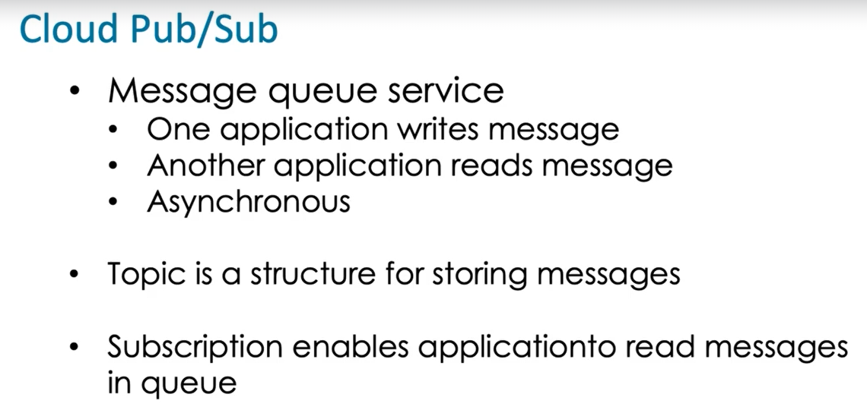

Big data > Pub sub > create topic > topic id > google / customer managed key

We write msg to the topic , first we need a subscription .

Big data > Pub sub > create Subscription > id > expiration >

Pull (read) / push(write) subscription

We can publish messages on the topic . If we pull message then we have to acknowledge it .